Michael Chillemi Project 2

Discrete Math

Part 1

1.

Graph



New Jersey

Manhattan



Bronx



Queens



Brooklyn

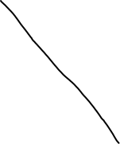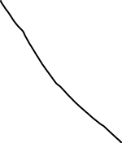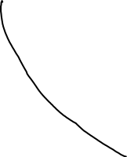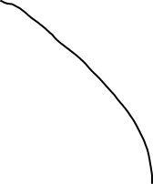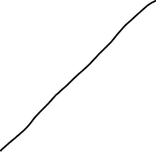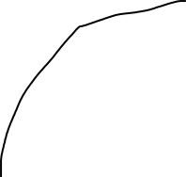

Part 2

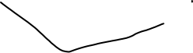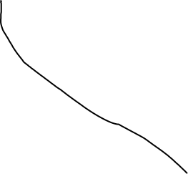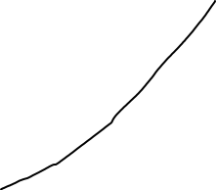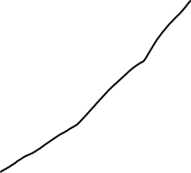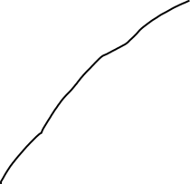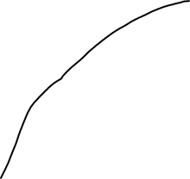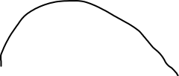

Part 2

7. cheapest way

Nj->Lincoln Tunnel->Manhattan->Third avenue bridge->Bronx->Willis avenue bridge->Manhattan->Queensborough bridge->Queens-> Queensborough bridge ->Manhattan->Williamsburg bridge->Brooklyn->Manhattan Bridge->Manhattan->Holland tunnel ->NJ

$6+Free+Free+Free+Free+Free+Free+Free= $6 for tolls for the total trip.

2.

New Jersey = 3 edges

Manhattan = 13 edges

Bronx = 3 edges

Queens = 3 edges

Brooklyn = 4 edges

3. I found that the graph has neither a Euler Circuit or a Euler Path because in a Euler Circuit every vertex needs to be even. It is also not a Euler path because you cannot hit every vertex without going over some edges again.

4. There is not a cut vertex in the graph. If you remove New Jersey, Bronx, Queens, Brooklyn you just remove a point but it doesn’t make the graph disconnected because everything is connected Manhattan. If you remove Manhattan then it removes all the edges and you will just have 4 points with no connection.

5. Yes it has a Hamilton Circuit because you can reach every vertex and return to the starting vertex without visiting every edge.